Rules / Lore

TS4 - Diffy Cult Legacy

Rules and Lore

⚠️Content Warning⚠️

Themes included in this challenge may not be suitable for all ages. Themes include: High Control Groups and manipulation. Content discussed in this document can be considered triggering to some audiences. As a general disclaimer, I will use the word “cult” synonymously with the phrase “High Control Group”.

**Note**: Some Generations' goals are to feel different aspects of High Control Groups. This may feel uncomfortable for some players. Please use your own discretion as to whether you will follow the rules or modify/skip different generations.

–This is a game, stay safe and have fun!

Table of Contents

Required Packs

Rules

Specific Rules

🏆The Leader Rule

When a Leader becomes an Elder,

When a leader dies suddenly

🔮 The Heir Rule

Lost Rebirths

Reincarnation

The Great Reckoning

🍿Popcorn Rules

🕯️ Penance Retreat Rule

Week of Penance

Choosing Ceremony

Soul Points

Scoring Summary

Becoming a Leader

Assigning a New Leader

Life Cycle

Life and Death

Life and Death Protocol

● Dies as an Elder of the Cult

● Dies as the Leader of the Cult

● Dies as a member of the cult

● Dies Exiled / Townie Deaths on Cult Land

● Reincarnation

Getting Started

Roles in the cult

Cult Founder

Role in the Challenge:

Cult Leader

Role in the Challenge:

Cult Initiate

Role in the Challenge:

Cult Follower

Role in the Challenge:

Cult Elder

Role in the Challenge:

Spirit Guide

Role in the Challenge:

Lore

🧭 Generational Arc Overview

🌾 Gen 1 — The Believer

Gen 2

Gen 3

Gen 4

Gen 5

Gen 6

🐑 Gen 7 — The Outcast

Gen 8

Gen 9

Gen 10

# Required Packs

* The [Sims 4](https://www.ea.com/en/games/the-sims/the-sims-4) Base Game
  + Enchanted By Nature
  + Life and Death
  + Getting Together
  + Business and Hobbies
    - Or Live in Buinesses Mod
* Honestly, you could get by with substitutions for everything, just by going with the spirit of the lore. However, I have these packs and a few more so I will be using them.

# Rules

There are several rules for this Challenge. The now popularized term “High Control Group” has become synonymous with the word “Cult”. These rules are meant to challenge the player in different aspects of high control groups, following the real trend of high control groups.

* This Challenge is split into three parts
  + Gen 1-3
  + Gen 4-6
  + Gen 7-10
* During the middle section you will no longer just be playing in a single household.
  + You will be Pop-Corning around

## Specific Rules

These rules span across all of the generations, except where explicitly stated

### 🏆The Leader Rule

While the majority of your playthrough in this challenge, you will be playing as “The Leader,” you are not always guaranteed the spot; in fact, some generations will outright decline it.

When a Leader becomes an Elder, they will pass along the position of Leader and become an Elder of the cult. This is a **specific role** in the cult.

### When a Leader becomes an Elder,

they will pass along the position of Leader and become an Elder of the cult.

This is a **specific role** in the cult.

1. Pick a [Chosen House](https://www.notion.so/Chosen-Household-28feed3eb831805cbff3dbc18d19f9d2?pvs=21)
2. Assign from that house an [Acting Cult Leader](https://www.notion.so/Acting-Cult-Leader-28feed3eb83180818d97fe6e86c930a1?pvs=21)
3. Throw a party
4. Spin for a Blessing

### When a leader dies suddenly

1. Pick a Chosen House
2. Assign from that house an [Acting Cult Leader](https://www.notion.so/Acting-Cult-Leader-28feed3eb83180818d97fe6e86c930a1?pvs=21)
3. Begin a [Week of Penance](https://www.notion.so/Week-of-Penance-28feed3eb8318032a9b9e26af36e48bb?pvs=21)
4. When complete, impregnate a sim in the main household and start the next generation

### 🔮 The Heir Rule

“Every light returns as its own shadow.”

Each generation begins with the Leader’s rebirth **within** the bloodline.

* The new heir must be a newborn to a descendant of the prior leader
* Carry one inherited trait or aspiration
* The birth household becomes the “Chosen Branch”
  + They now take over the Cult estate
  + The “Acting Leader” will abdacate when player either graduates/drops out of highschool.
    - +3 SP for any groups you take over without using cheats

#### Lost Rebirths

If the leader’s soul manifests outside the family, +3 SP and triggers a “Week of Penance”

* Week of Penance
  + Build a “Shrine of Return”
    - must cost more than §5, 000
    - Have the acting leader meditate in there for the remainder of the sim week (minimum of 4 days)
    - Should represent the leader who has passed on
      * You cannot reuse a shrine
  + Live simply for the week
    - No electronics
    - Meditation
    - Skill focus
  + Have a Choosing Ceremony
  + -1 SP When completed

#### Reincarnation

This is not just reserved for Leaders. I also highly recommend recycling characters into side households to further the line instead of playing them through.

You should be keeping all tombstones and urns on the cults lot.

* If they die and have the **rebirth** ability
  + Become reborn as an infant and use the Pop-Corn household spinner to see where they land.
  + +3 SP
* If they die and **do not** have the rebirth ability
  + “Spirit Guide”
    - Assist the ghost in passing on OR
    - Resurrect them
      * +2 SP

##### The Great Reckoning

Every 10 weeks hold a ritual and summon all the ghosts

Spin The Great Reckoning Wheel and see if you get a:

* Reunion
* Uprising
  + Spin a Tier 1 penance
  + Spin a Tier 2 penance
  + Start a fight with the person who has the lowest relationship with you.
* Peace
  + One of the ghosts transcends, either through rebirth or moving on

### 🍿Popcorn Rules

Durning Generations 4-6

### 🕯️ Penance Retreat Rule

When the weekly tally has **3+ Shadow Points**, you must the Acting Cult Leader enter seclusion for 24 in-game hours:

* Lock doors to keep others out.
* No phone, no TV, no social media.
* Only meditate, bathe, garden, or write.
* After 24 hours, remove all Shadow Points
  + If playing with mods:
    - add a moodlet that provides Focus
    - Fill the household needs AFTER a successful retreat

If she refuses to retreat, a fracture forms — her aura darkens (use darker clothes/makeup) until the next retreat occurs.

### Week of Penance

* Add 3 SP
* Build a “Shrine of Return”
  + must cost more than §5, 000
  + Have acting leader meditate in there for the remainder of the sim week (minimum of 4 days)
  + Should represent the leader who has passed on
    - You cannot reuse a shrine
* Live simply for the week
  + No electronics
  + Meditation
  + Skill focus
* Have a Choosing Ceremony

### Choosing Ceremony

When your heir becomes an Elder

1. Throw a party and invite all eligible Acting Leaders to attend
2. Either
   1. Have an elimination event where the last one is chosen
   2. Spin the Pop-corn household and choose among the available there
3. Move the Chosen Household in
   1. Only the Acting Leader and your Heir must remain on the Cult Lot

### 

To the top

# Soul Points

Soul Points are this challenge's version of “faith”

## Scoring Summary

* Earning Shadow Points
  + **+1** Missed sunrise meditation
    - Every morning between 5 am and 7 am, you must meditate
  + **+1** Negative Emotion for more than 6 in-game hours
  + **+1** Yells, insults, or fights with any sim
  + **+1** Breaks vegetarian rule
  + **+1** Death of a sim on cult property
  + **+2** Death of a follower
  + **+2** Cancels a wellness class mid-session
  + **+3** Accepts a career
    - Exception for aspirations that require a career (See rules for further explanation)
  + **+3** Uses vampire powers or dark magic
* Cleansing Shadow Points
  + **-1** 3-hour meditation alone
  + **- 1** Write in your journal about “truth” or “guilt”
  + **-2** Donate §2,000 to the balance sheet
  + **-3** Complete a yoga or meditation aspiration milestone
  + **Reset** (Penance Retreat)
    - Spend 24 sim hours
* Need to be added
  + Cleansing
    - **-2** gain a Spirit Guide
    - **-1** completing “Week of Penance” for lost heir
    - **-2** completing “Week of Penance” for dying as a cult leader
    - **-2** Peace through the Great Reckoning

To the top

# Becoming a Leader

✅ ❌

To the top

# Assigning a New Leader

To the top

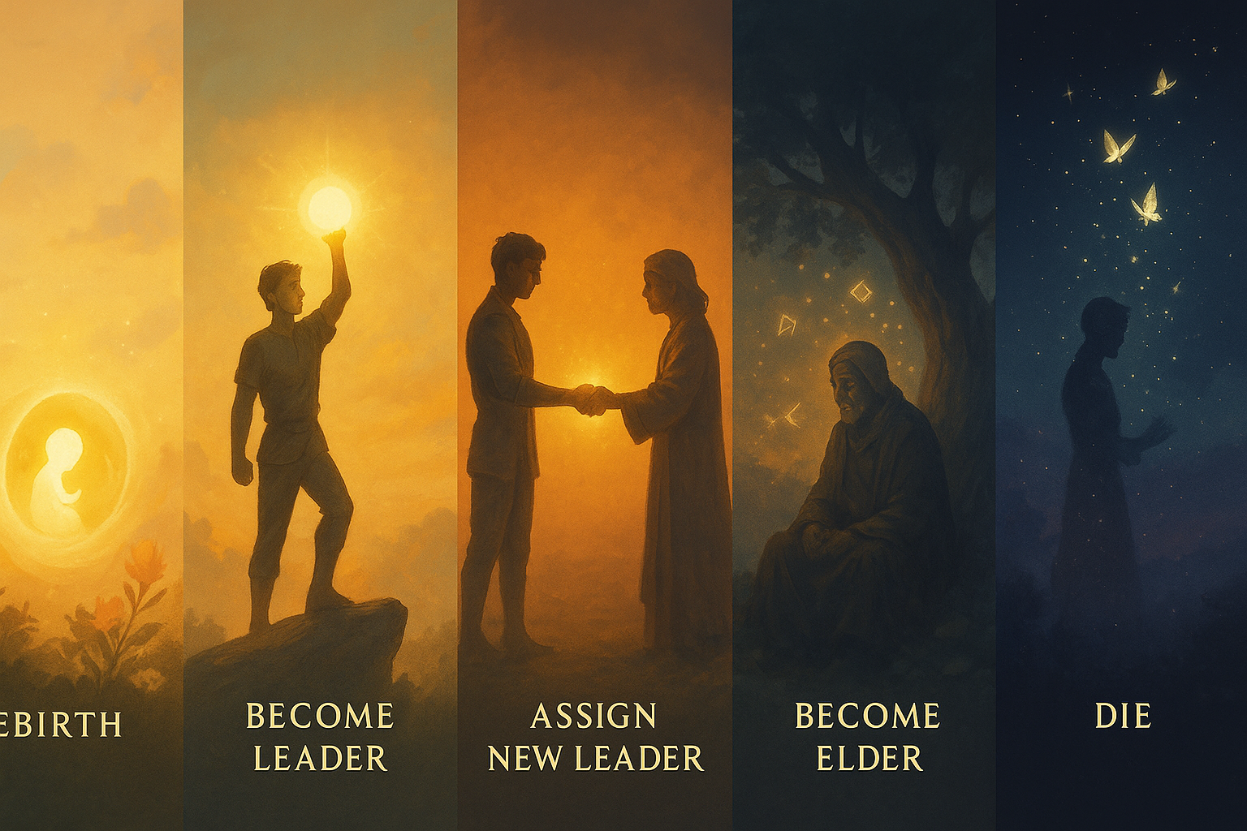

# Life Cycle

1. **Rebirth**
   1. Use Pop-corn House wheel to pick the new chosen household
      1. If more than one parent is available in the household, use your best judgement
2. **Become Leader**
   1. Rise through the ranks of the social groups to become the leader of the cult
3. **Assign** **New Leader**
4. **Become Elder**
   1. Use this time to finish up any goals that are left
5. **Die**
   1. Any left over goals is +3 SP

To the top

# Life and Death

During the course of the playthrough you will be using the rebirth system from Life and Death.

The character you start with, will be the same character you are playing in Gen 10, you are living one continuous life within the cult experience.

## Life and Death Protocol

### **Dies as an Elder of the Cult**

* + Have a funeral event
  + Spin the Blessing Wheel
  + Reset SP

### **Dies as the Leader of the Cult**

### **Dies as a member of the cult**

### **Dies Exiled / Townie Deaths on Cult Land**

### **Reincarnation**

This is not just reserved for **everyone but your main sim**. I also highly recommend recycling characters into side households to further the line instead of playing them through.

You should be keeping all tombstones and urns on the cults lot.

* If they die and have the **rebirth** ability
  + Become reborn as an infant and use the Pop-Corn household spinner to see where they land.
  + +3 SP
    - alternatively you can make them a Spirit Guide, that is up to you.
* If they die and **do not** have the rebirth ability they become a Spirit Guide
* If you lose your main sim “soul” and have to create a new one
  + Trigger a “Week of Penance”
    - -1 SP at its completion

To the top

# Getting Started

I do recommend looking through the upcoming generation before committing any major changes to your save.

* You do not need to start in a fresh save, however, you will need to have neighborhood stories on during Gen 4-6 at a minimum
  + It is my recommendation to switch saves when you move house.
    - To do so: Upload your sims/home to your gallery and then drop them into your new save. (You can do this with lots as well)
    - The downside is that social groups will not follow you to a new save, so you will have to start over.
      * Ideal switch time is Gen 7 when social groups are dropped for one generation and you are forced into isolation
* Founding Sim
  + Check 🌾 Gen 1 Lore for details on sim
  + Leader Rule is not in effect until Generation 2
  + Check the Heir Rules for information on who comes next
* Save Set up
  + Auto Aging On, Lifespan is up to you. I wouldn’t recommend short.
  + Autonomy Full
    - You can turn it off for selected sim.

To the top

# Roles in the cult

Hierarchy is one of the main factors when it comes to maintaining a cult. Although the model appears to be linear, it functions more like a nebula where the center point is the leader. This is why some cults are able to survive without the leader, and some movements evolve completely in spite of the leader.

In order to make the rules of the cult fit within the Sims universe, I had to be a bit creative with my thinking. Cults use your position within the cult as a bit of a reward system. While it is possible to mimic this it creates a bit of tediousness that I really don’t enjoy. In order to feel the strain of managing so many people, you must use your social groups to create a group for **Initiates**, **Followers** and **Elders**. Feel free to name them however you wish.

## Cult Founder

**Historical Role**:

As the name suggests, this is the person who not only leads the cult, but founds it. They will eventually turn into a mythical type of person as the generations progress and the memory of them turns into lore instead of historical remembrance.

### **Role in the Challenge**:

**This is our Generation 1.**

* Not Bound by Cult Leader role regulations as they are the one who sets it up.
* Must be able to do rebirth at the end of their life
* They are able to romance any one that you choose
  + I recommend moving sims out onto their own lot as soon as they become a young adult, but thats completely up to you
    - Reminder that there is a hard cap of 20 sims on a given property in sims

## Cult Leader

**Historical Role**: fd

### **Role in the Challenge**:

## Cult Initiate

**Historical Role**: fd

### **Role in the Challenge**:

## Cult Follower

**Historical Role**: fd

### **Role in the Challenge**:

## Cult Elder

Historical Role

### **Role in the Challenge**:

## Spirit Guide

Historical Role

### **Role in the Challenge**:

To the top

# Lore

This is a breakdown of each Generation in the legacy, what they mean, and why they were included.

*It is not necessary to play the challenge, but it provides a deeper context for what this challenge is, as well as how to play each generation.*

**Note**: Some Generations' goals are to feel different aspects of High Control Groups. This may feel uncomfortable for some players. Please use your own discretion as to whether you will follow the rules or modify/skip different generations.

–This is a game, stay safe and have fun!

## 🧭 Generational Arc Overview

1. Gen 1 — Builds belief

2. Gen 2 — Doubts it

3. Gen 3 — Spreads it

4. Gen 4 — Fractures it

5. Gen 5 — Heals it

6. Gen 6 — Exploits it

7. Gen 7 — Rejects it

8. Gen 8 — Records it

9. Gen 9 — Resurrects it

10. Gen 10 — Transcends it

To the top To Lore

## 🌾 Gen 1 — The Believer

To the top To Lore

## Gen 2

To the top To Lore

## Gen 3

To the top To Lore

## Gen 4

To the top To Lore

## Gen 5

To the top To Lore

## Gen 6

To the top To Lore

## 🐑 Gen 7 — The Outcast

To the top To Lore

## Gen 8

To the top, To Lore

## Gen 9

## 

To the top, To Lore

## Gen 10